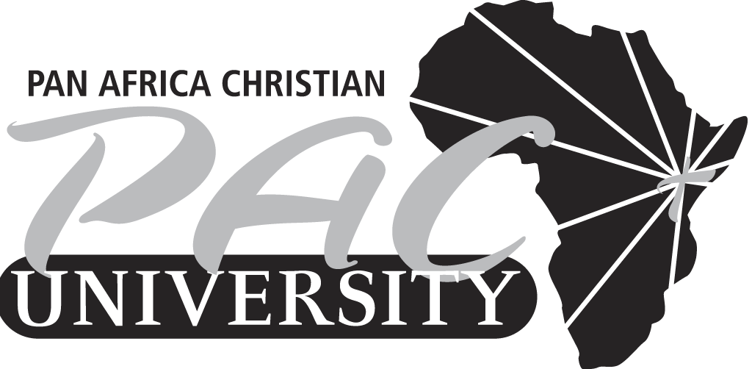

PAN AFRICA CHRISTIAN UNIVERSITY
END OF TERM EXAMINATION
UCC102/COD1213: BIBLE SURVEY & DOCTRINES
MONDAY NOVEMBER 24TH, 2014
1800HRS – 2100HRS

INSTRUCTIONS
- This exam paper has Two Sections A & B
- Answer All questions in section A and Two from section B. question 1 in section B is compulsory
- Write your student number on the answer booklet provided.
- Read all questions carefully before attempting.
- Bibles will be provided.

SECTION A (30 Marks)

- State and explain four analogies that help us to explain the Trinity. (4 marks)

- Define the following terms:
- Justification (2 marks)
- Adoption (2 marks)

- Explain three things that help you to understand the pre-existence of Christ.
(4 marks)

- Describe four pictures that give us an idea of the richness of the Church. (8 marks)

- Explain two purposes of the Church, and state the nature of ministry today. (4 marks)

- Elaborate three purposes of punishment as a result of sin. Give Biblical examples where applicable. (6 marks)

SECTION B (30 Marks)
Answer question 1 and any other question.
- Describe five views of God. Give examples of religions that hold these views in each view. (15 marks)

- There are a variety of ways through which the Holy Spirit works today. Explain in detail three different ways and give Scriptural references. (15 marks)

- Discuss in detail five areas of the exaltation of Christ. Give Scriptural references.
(15 marks)
- Evaluate three things that we can learn from the first and second accounts of the creation of man. (15 marks)

